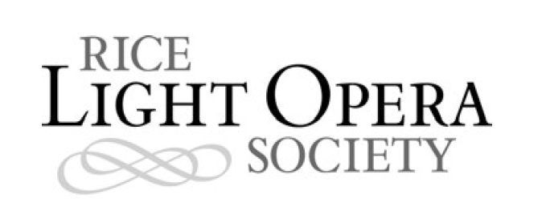

FOR IMMEDIATE RELEASE
March 25, 2010
CONTACT: Gillian Kruse
Website: www.hailpoetry.com
Email: gillian.kruse@gmail.com
Phone: 281-507-0520

TAKE A TRIP TO A FAR AWAY LAND IN GILBERT AND SULLIVAN'S “THE MIKADO”

The Rice Light Opera Society will present Gilbert and Sullivan's famous comic light opera “The Mikado” in six performances April 8-10 and 14-16, 2010.

The most popular of Gilbert and Sullivan’s collaborations, and possibly the most popular light opera of all time, “The Mikado” has been entertaining audiences worldwide for more than a century. Set in a fictional land called Japan, “The Mikado” follows Yum-Yum and Nanki-Poo, two young lovers who keep finding the laws of the Mikado in the way of their wedded bliss. Add into the mix Yum-Yum’s guardian, Ko-Ko, the town’s awkward but well-meaning tailor-turned-executioner and Pooh-Bah, the snobbiest nobleman you’ll ever meet (who also happens to hold every civil position in town, from Groom of the Back Stairs to Archbishop), and you’ve got a recipe for calamity and laughs when The Mikado himself determines to make a visit to the town of Titipu.

“The Mikado” will be performed on the Rice University campus in the Brown College Commons. Performances will be April 8-10 and 14-16. The Thursday, April 15 show will be at 10 p.m.; all other shows will begin at 8:30 p.m. Tickets are $10 for the general public and $5 for the Rice community and children under the age of 12. For directions, parking information, and ticket reservations, please visit http://www.hailpoetry.com.

The Rice Light Opera Society has staged productions since 2002, most recently performing “The Pirates of Penzance” in the spring of 2009. The mission of the society is to increase awareness and appreciation of light opera in the Rice and greater Houston communities.

“The Mikado” was the ninth collaboration between W.S. Gilbert and Arthur Sullivan. The opera premiered on March 14, 1885 at the Savoy Theatre, where it ran for 672 performances. Gilbert, the duo's librettist, was an accomplished satirist known for a series of illustrated verses written under the pen name Bab. Sullivan, the composer, was often called the “English Mendelssohn,” but his genius was most evident in the lighter comic songs he wrote with Gilbert. Sullivan's solo works include the opera Ivanhoe and the hymn “Onward Christian Soldiers.” Gilbert and Sullivan's operas were wildly popular in their time and are still performed worldwide today.

###

